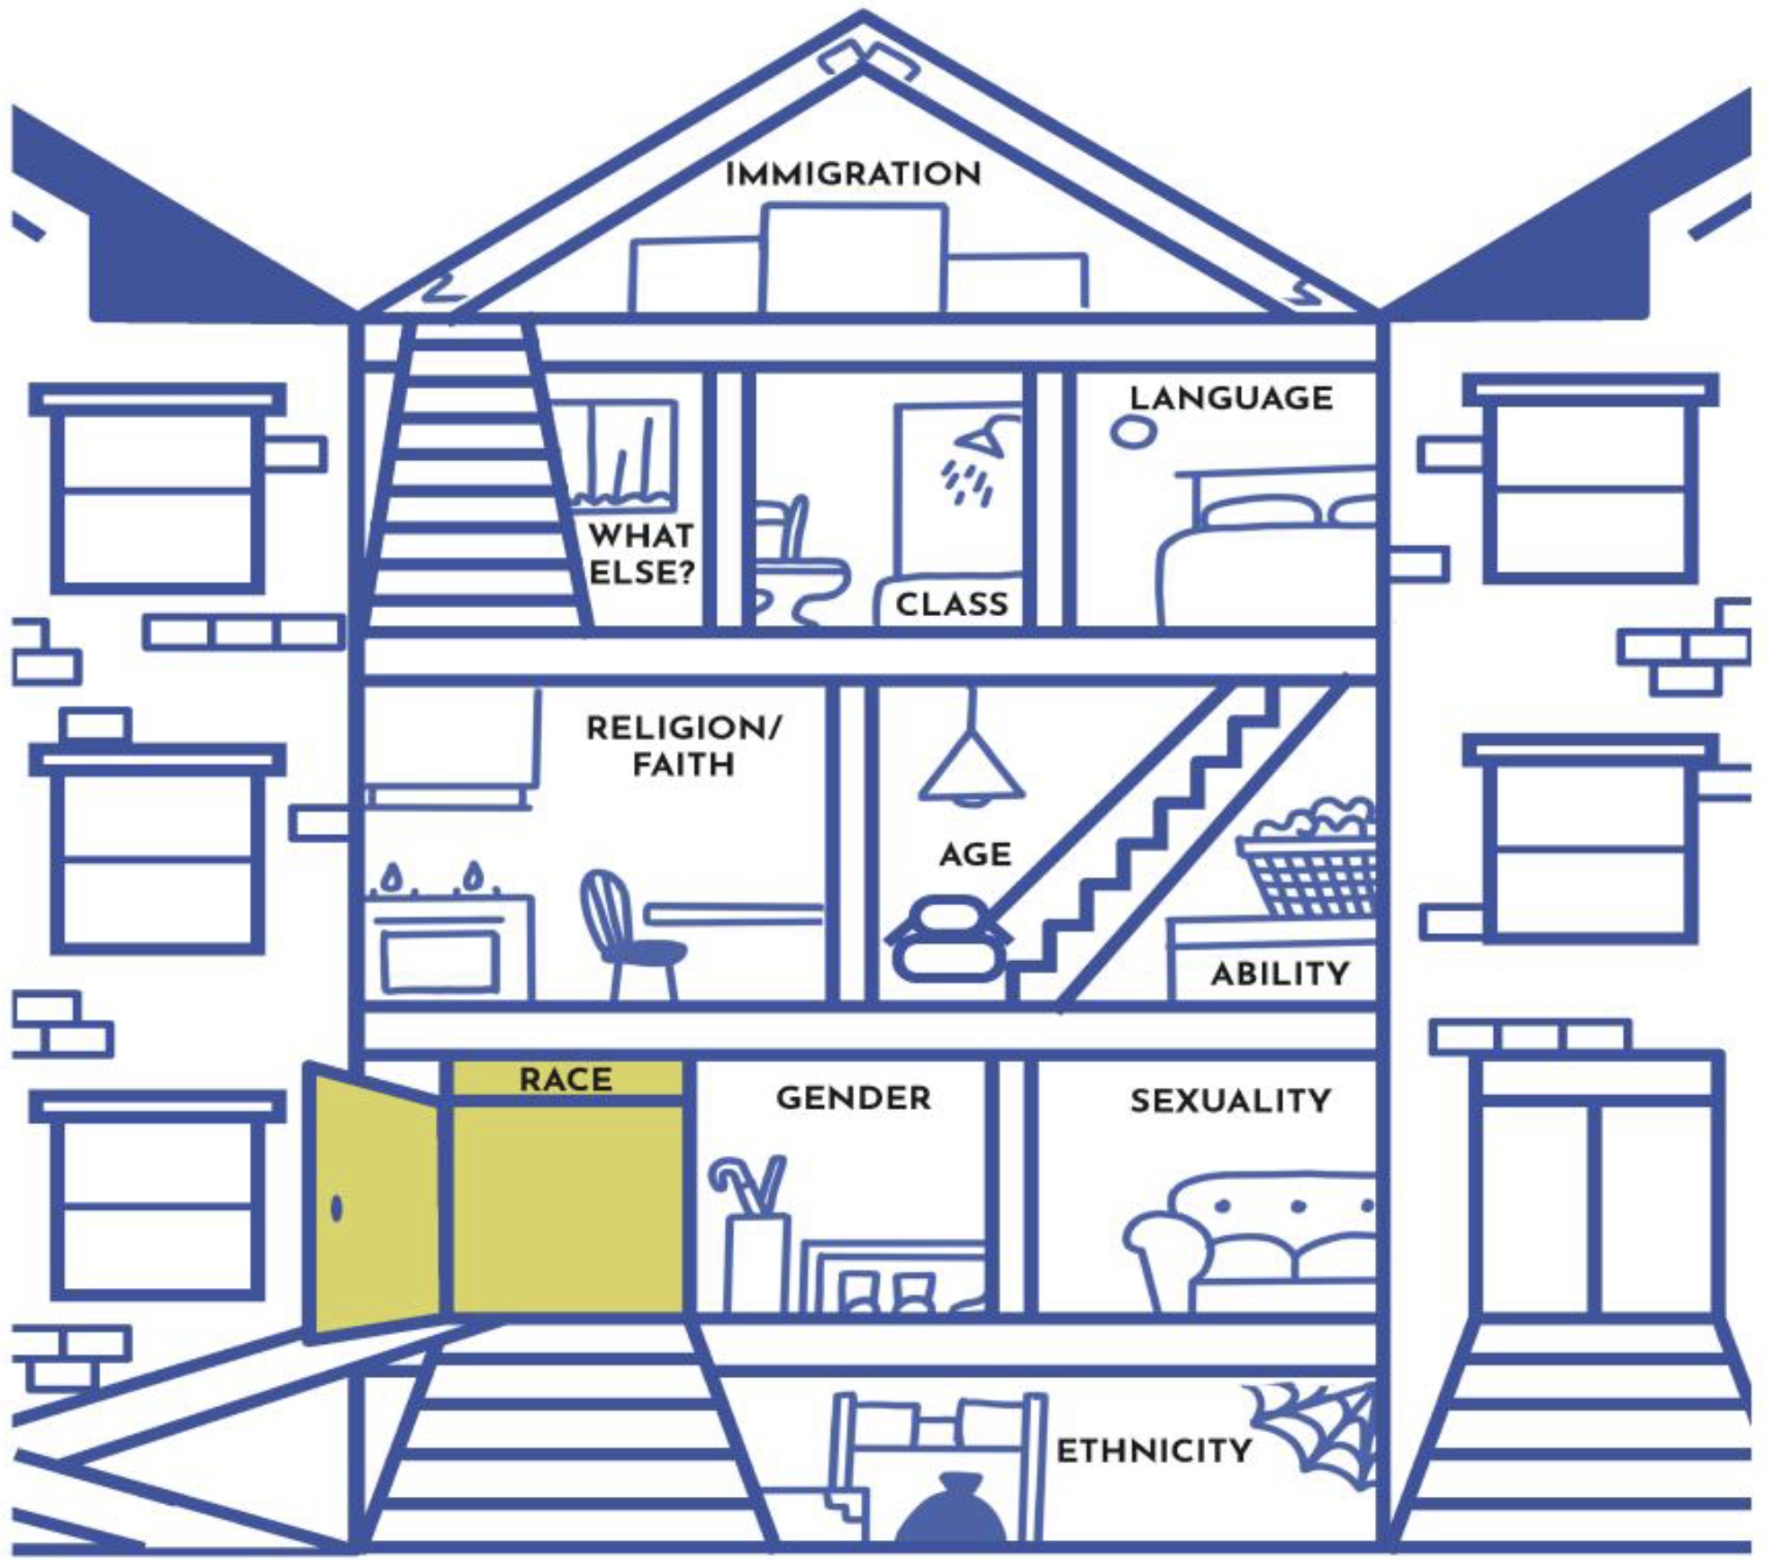

Redistributed with attribution to @TeamDynamics MN LLC

