Supervision
  - Technical & Reflective
Date & Name:

opening ritual
[Start---End Times]
Priority List: PTO/Training/Hours/Attendance
Project Work
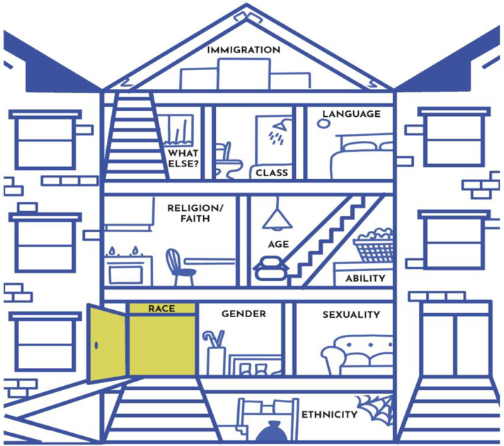
Caseload Misc.
To-Do/Follow-Up

[Start-End Times]

Reflective Supervision
- What’s coming up for you this week? What are you noticing about your patterns at work? With peers? With staff you supervise? Etc.
- What parts of your identity were most salient this week? When?
- In what ways were you invited to include preferences in workflow or process that are different than yours?

Ending ritual

Coaching
  - Adaptive
Date & Name:

Attend to self first

[Start-End Times]
What am I feeling?
What are these feelings trying to tell me?
How can I anchor in my compass/values/assumption that support this work?
How do I anticipate the role that my own identity will play in my ability to coach today?
Who can support me in this process?
_________________________________________________________________________________________
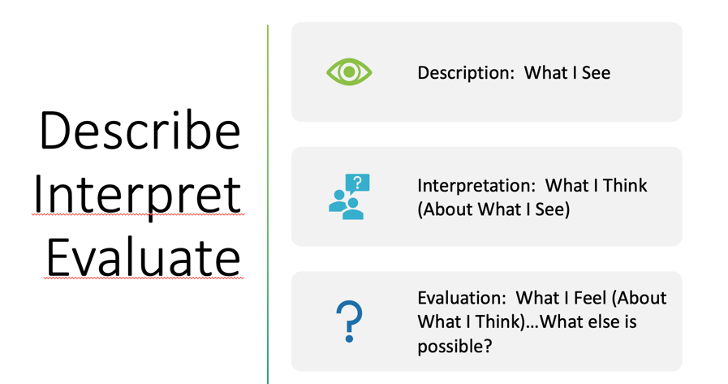

Surface. Recognize. Explore. Create.
Surface: Name and acknowledge current situation in organization, classroom, workplace, interaction between X&Y.

Recognize: Impact. What is currently driving the current surface and how am I contributing? Mental models? Identity? Storytelling?

Explore: Emotions. Name/Acknowledge, Explore/Understand, Except/Release.

Create. New practice. Co-plan, role-plan, support additional capacity building.

